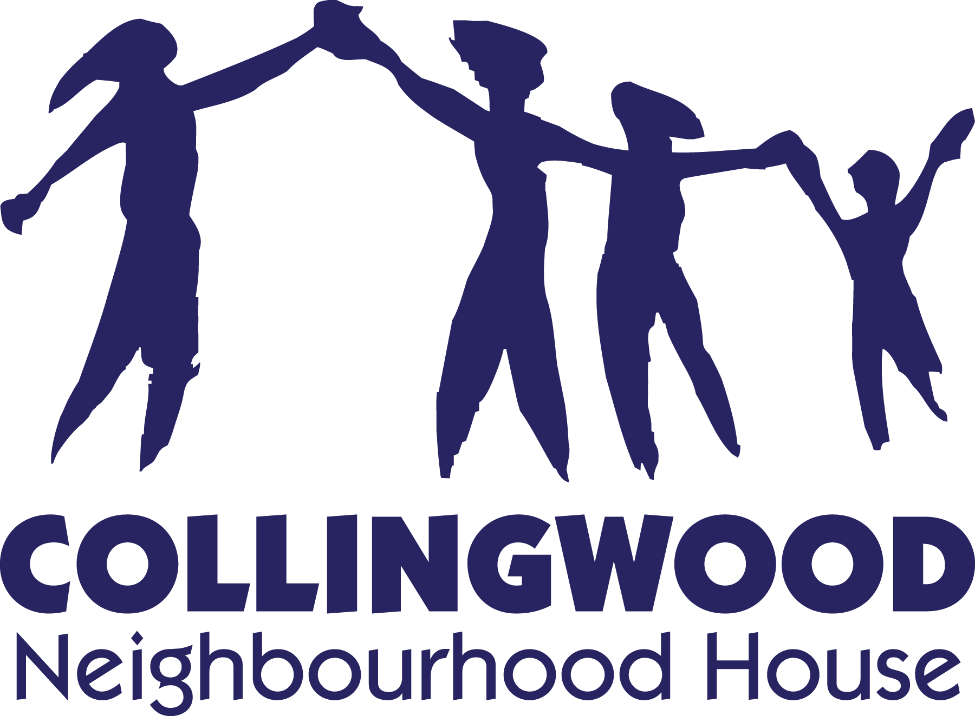
Kids Kitchen Online Registration Form
Kids Kitchen Online is a take-home cooking program for children and youth between the ages of 12-18. Each week, participants will be provided with ingredients for a weekly cooking activity. During the week, participants will connect online with the program facilitator to discuss the dish and cooking methods. Once the dish is completed, participants will be asked to share their feedback and a picture of their work.
Program Dates: February 26, 2022 – March 26, 2022 (5 sessions)
Cost: $50 Ingredient Box Pick-up: Fridays day before class 5:45pm – 6:30pm
Zoom Demonstration Sessions: Saturdays, 12:00pm – 1:00pm
Program leader Sami will meet with participants weekly on Zoom to share details about the recipe, cooking methods and to answer any questions.
- Participants will choose a time to prepare the recipe on their own time and will share photos and feedback with participants
- Program times and menus may change in response to program needs

Participant Information
Full Name: |  | Age:
School: |  | Grade:
Email Address: |  | Phone Number:
Home Address: |  | Postal Code:
[Optional Demographic Information]
Did you immigrate to Canada? ☐ YES ☐ NO
If Yes, which country were you born? _______________ How many years have you lived in Canada? _______
Do you identify as an Indigenous person in Canada such as First Nation, Métis or Inuit? ☐ YES ☐ NO
Do you or your family have any food allergies or food requirements we need to be aware of:

Parent/Guardian Information
Full Name: |  | Phone Number:
Email Address:
Do you have any concerns with your child’s ability to perform certain kitchen duties (i.e. cutting vegetables, handling raw meat, etc.)? If so, certain modifications to the recipe and food preparation can be accommodated.
Consent and Waiver
As parent/guardian and participant, I understand the that the cooking activities will take place at home and Collingwood Neighbourhood Staff will not be able to provide supervision. I also understand the following risks, and knowingly and willingly, accept these risks and waive Collingwood Neighbourhood House of any responsibility of risk or liability.
Potential risks to be aware of:
- Cuts/scrapes from sharp cooking tools (knives, peelers, graters)
- Burns from hot oil, boiling water or cooking elements
- Food-borne illnesses from improper food handling
- Transmission of germs and viruses
Steps taken to mitigate chance of risks:
Please note it is strongly recommended that appropriate supervision is available at home when participants are engaging in cooking activities.
- Information session through zoom
  - Program instructor will provide detailed guidance through each step of the recipe, highlighting specific steps where extra care should be taken
- Food Safe practices
  - Program instructor is certified with Food Safe Level 1, ensuring current safe food handling guidelines are followed
- Covid-19 considerations
  - All packaging and surfaces touched will be sanitized appropriately
  - Appropriate personal protective equipment will be used and physical distancing measures will be observed during shopping and package preparation
  - Package pick-up will follow non-contact practices
- Special considerations
  - If parents have concerns about dangerous cooking steps, please contact the program leader. We will try to provide options or suggestions for modifications.
As Parent/Guardian, I consent to my child participating in this program and understand and agree to waive Collingwood Neighbourhood House for the risks associated with participation of this activity.
Name of Participant: |  | Date:
Name of Parent/Guardian: |  | Signature:
Fore more details, questions or comments, contact:
Sami Iwama, Program Leader: kidskitchen@cnh.bc.ca or
Sanjeev Karwal, Director of Youth Services: 604-412-3844, skarwal@cnh.bc.ca

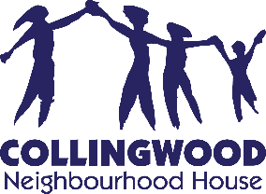
Kids Kitchen Online Zoom Usage Update

Dear Parents/Guardians,

The Kids Kitchen Online Program will use the Zoom video conferencing application to provide an opportunity for the program leader and participants to develop personal connection and to provide visual demonstrations.

To ensure our virtual interactions are safe, positive and respectful for both staff and participants, we must ensure everyone is aware and adhere to the following guidelines and practices.

- Video recording by participants will be disabled.

- If CNH and the program leader needs for any reason to record a session, all participants will be notified. The video will not be posted publicly without parental consent.

- Participants should not take screenshots of the Zoom session and no images/video should be posted on any public space or social media platforms.

Parents/Guardians/Participants who have concerns or would like to share their feedback, please contact Sanjeev Karwal, Director of Youth Services at 604-412-3844 or skarwal@cnh.bc.ca.

Thank you,

Sanjeev Karwal
Director of Youth Services
Collingwood Neighbourhood House

